

**A**

**PROJECTREPORTON**

**EXAMMANAGEMENTPORTAL**

**SUBMITTED BY**

**OMPRAKASH VISHWAKARMA.**

**KANHA SAHU.**

**AMEY MORE.**

**RABI NARAYAN SETHI.**

**SIMA BIKKAD.**

**PRIYANKA NIKAM.**

**Batch:2022-7904**

**Center:Salem-Alagapuram**

**UndertheGuidanceOf**

**Jayanth Vellingiri.**

**(EONMasterTrainer)**

**EduBridge**

**(Schoolofcoding)**

**Introduction**

In the world of internet, all tasks have been done through internet, so we have decided why Exam has not conducted through internet. For convert current exam system into digital exam system, we have built this small **Exam Management Portal** project. It will be more accurate and less time consuming and at the same time we can conduct more person exam at the same time and it will publish result in a very short time.

In an **Exam Management Portal** examine/users get their user id and password. This id is already saved in the system. When examine/user login to the server he/she get his/her profile already register. On the certain time examine start the examination. All answers given by examine are saved into the server with his/her profile information. **Exam Management Portal** also allows correcting the answer if the examiner needed to change any answer in the examination time duration, however, after the time duration any change will not allow. This also makes checking the answer easy and error proof as computers are more accurate than man and provide fast results too.

***Modules**:

* 1. Admin: Admin panel is specially designed to facilitate all tasks that need to be done or attempted by the student user.
  2. Registration: Before login user has to register his Name, Email-id, Contact number, User-id and Password to the system.
  3. Login: Login with the registered credentials and then move to the interface where available exams are shown.
  4. User: A user here is a student basically but we can say it, user, here. One needs to provide his details like name, address, number of the contact and email. These are required then enter his hit to make it saved in the database. Then we need to use the credentials for further access.
  5. Category: Admin can add multiple categories of quizzes.
  6. Question: Admin is responsible for all kind of operation in the exams of students he designs the question paper according to the subject in the portal.
  7. Quiz: Next, we have the interface for the students where one can after login see the quizzes available in their accounts and then they attempt that on particular venue provided for a particular duration of time and then he can move in the portal too the selection of attempt questions and can finish before time as their wish.

# *Software Requirements:

**Backend:** Spring Boot, Java12.

**Frontend:** Angular v11.2.10

**Database:** MySQL v8.0

**IDE:** Spring Tool Suite 4.

**Operating System:** Window10/Window11.

# *Screenshots :

## Home Page

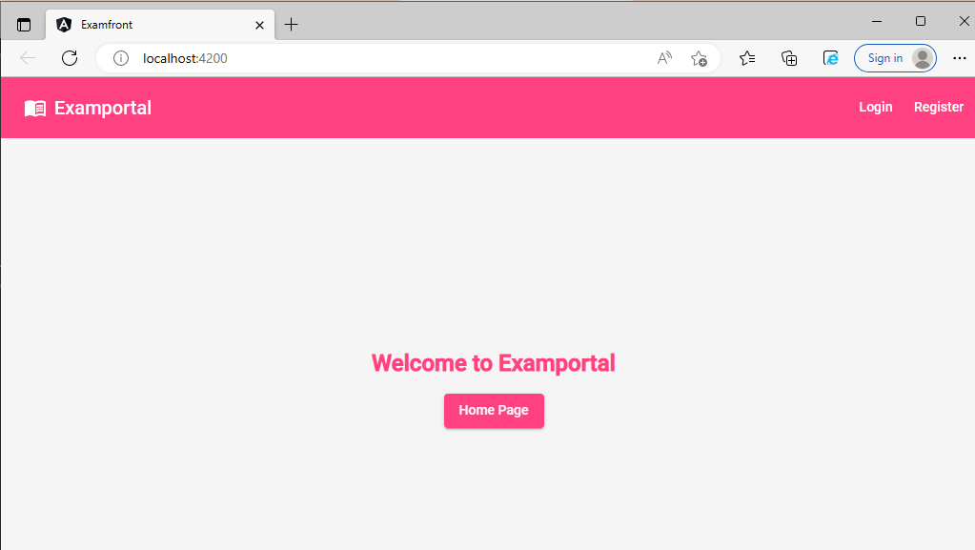

**LoginScreen**

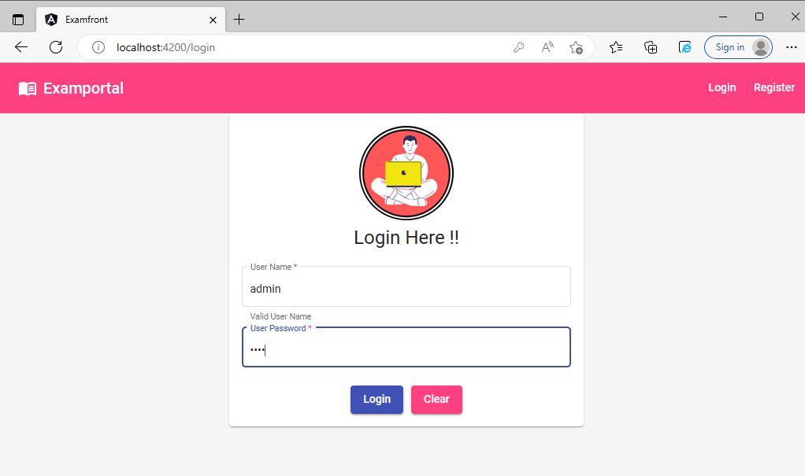

## Registration Page:

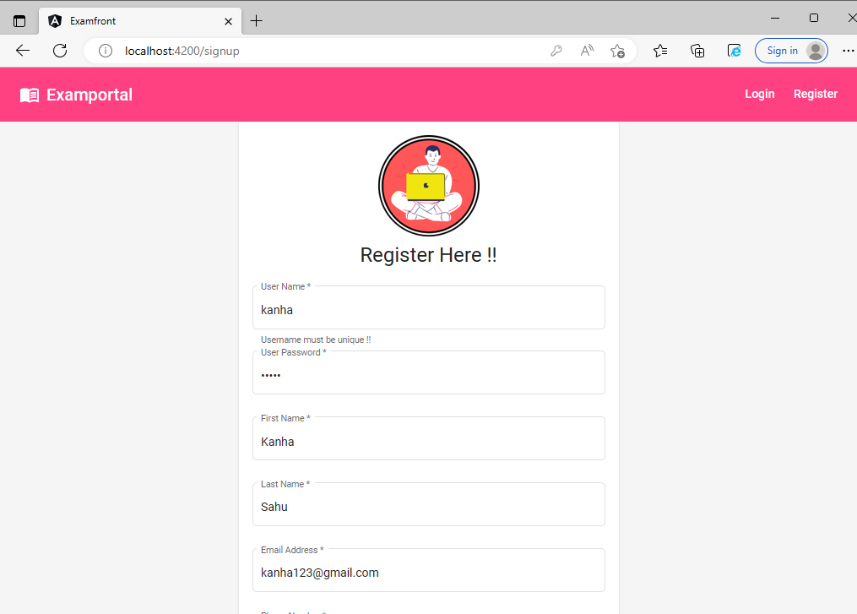

## Registration Successful:

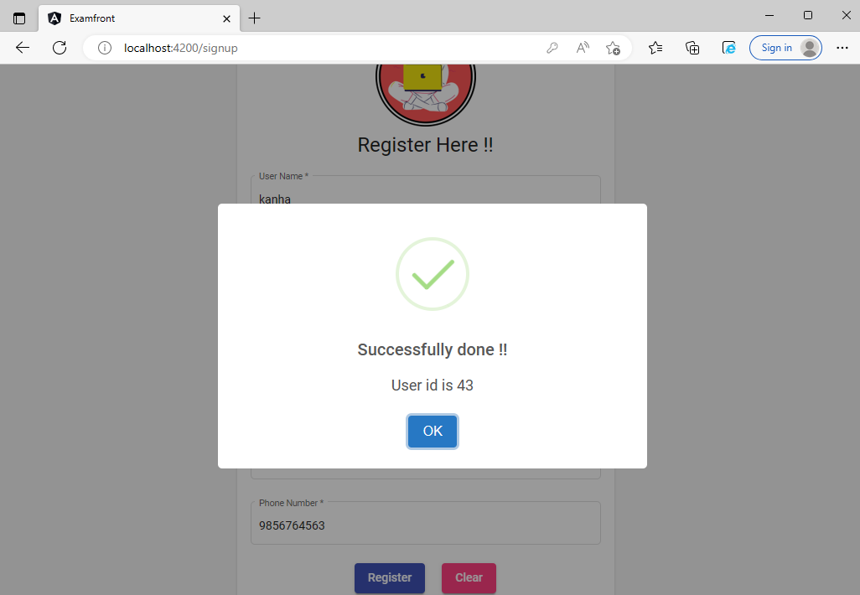

## Admin Page:

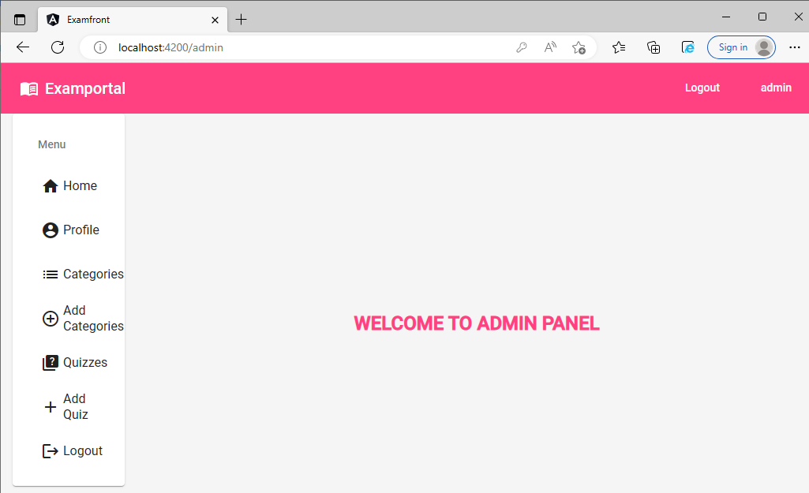

## Admin Profile:

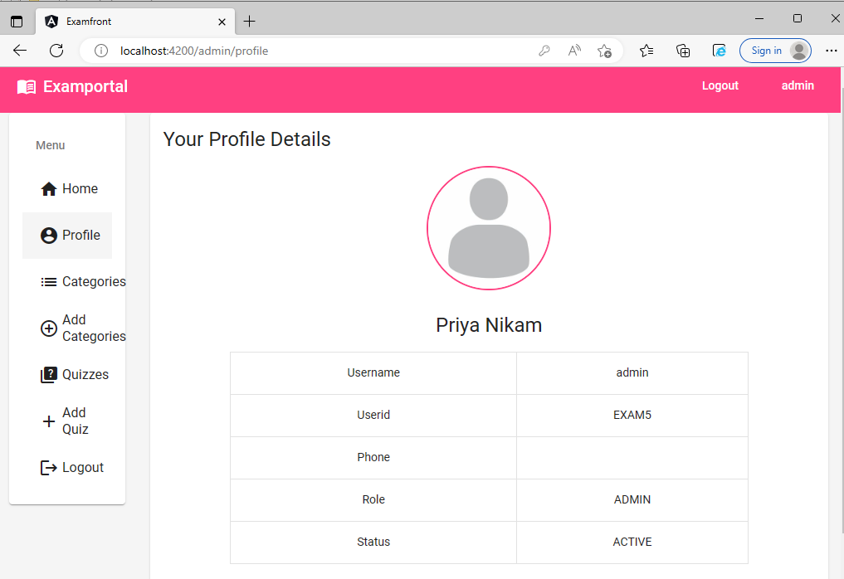

## Categories:

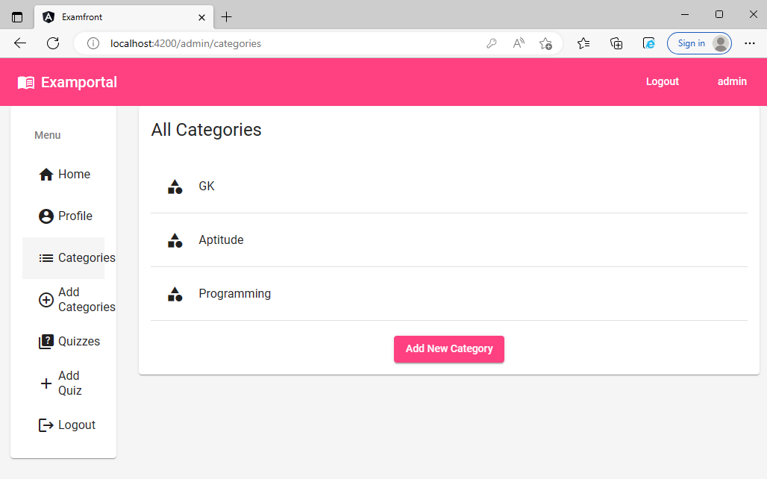

## Add Categories:

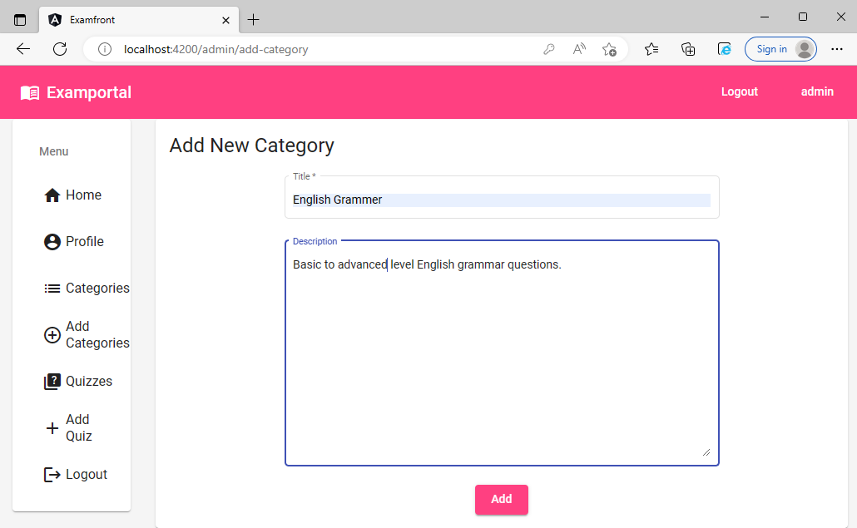

## Quizzes:

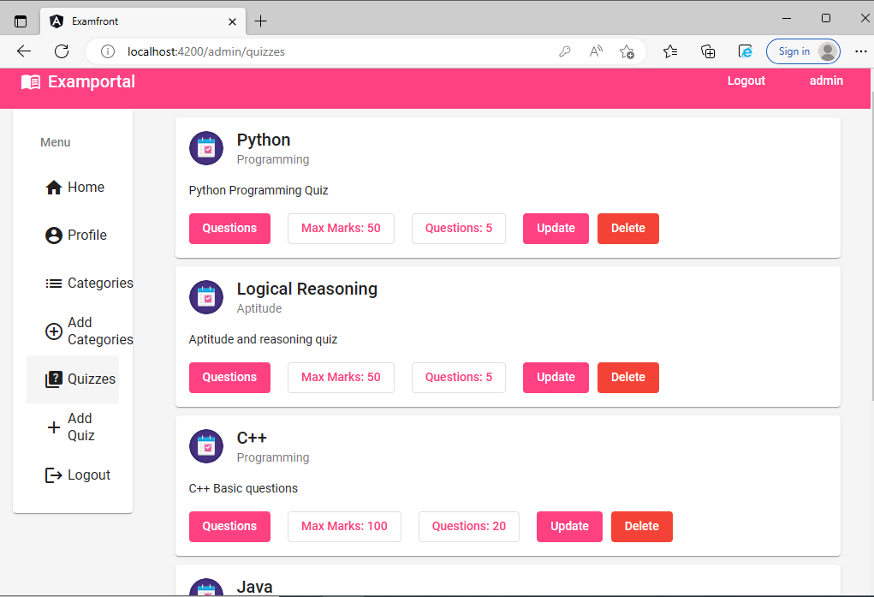

## Add Quiz:

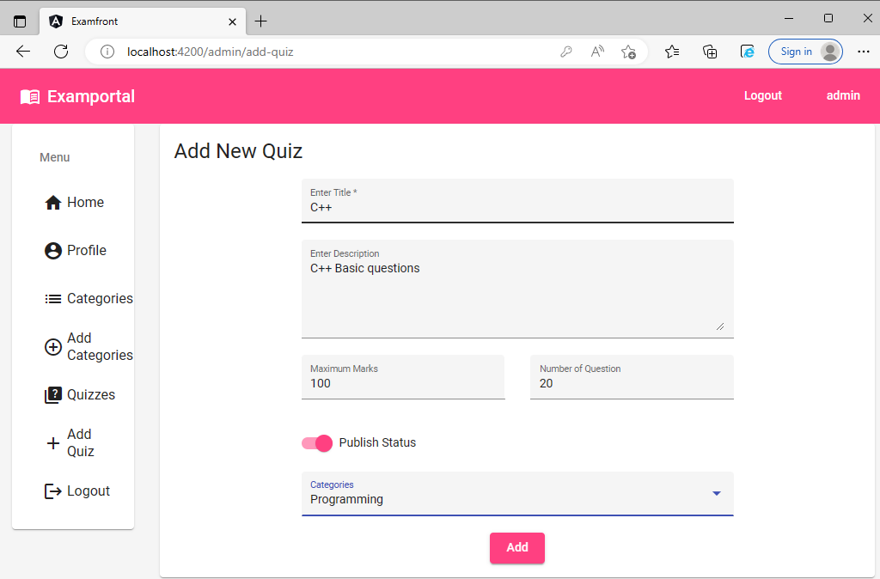

## Add Quiz Successfully:

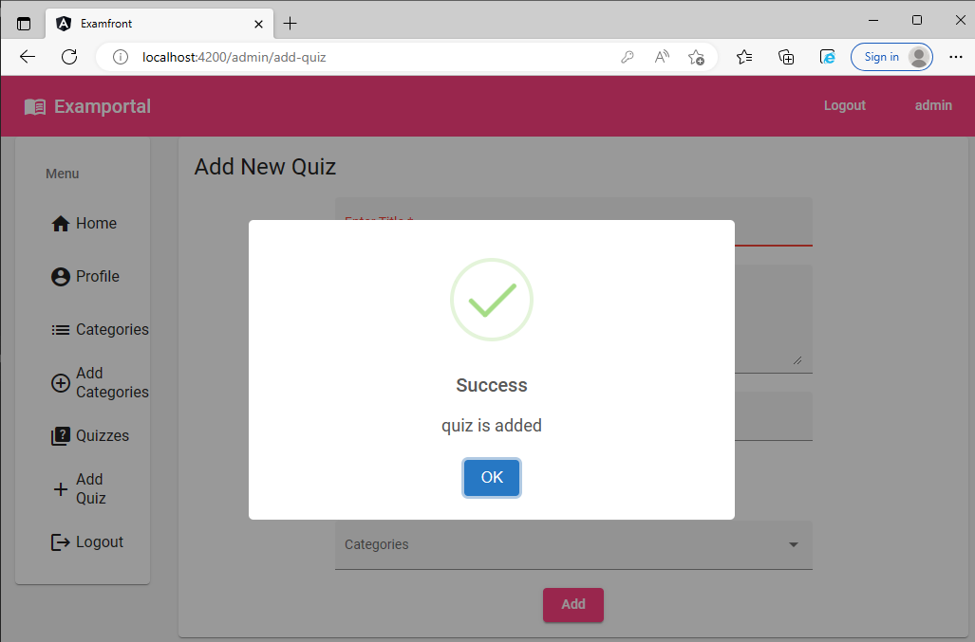

**User Page:**

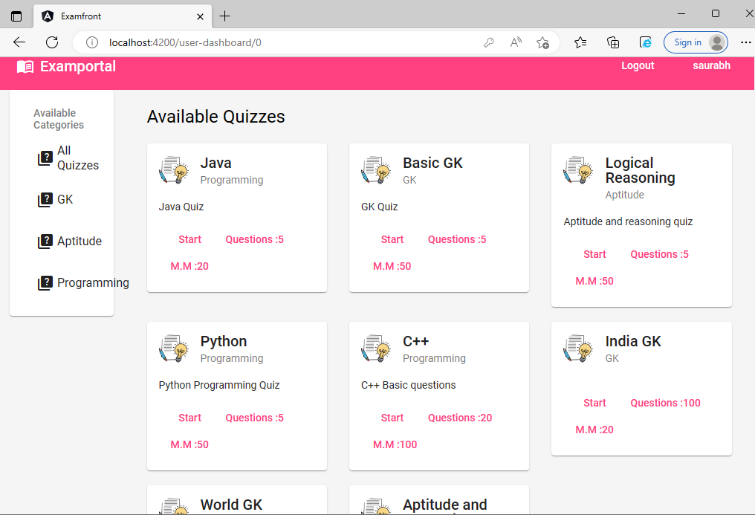

**GK Quizzes:**

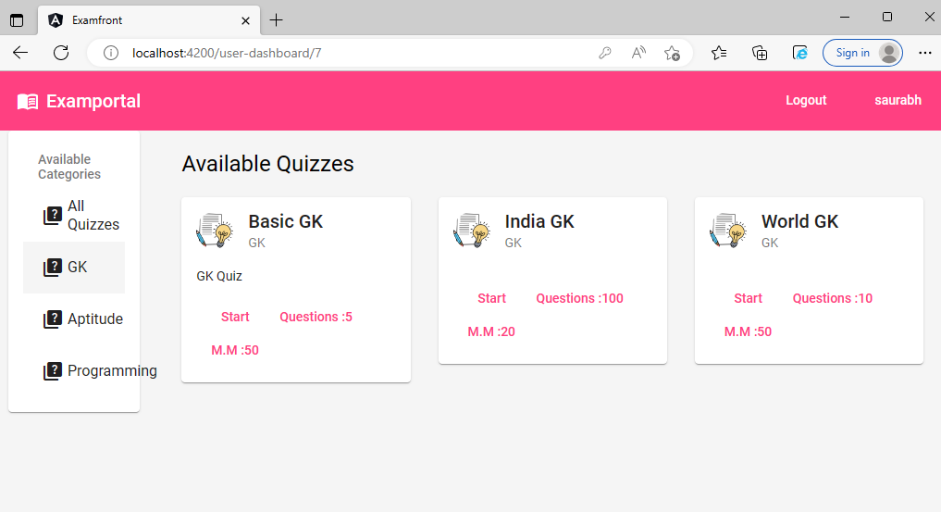

## Aptitude Quiz:

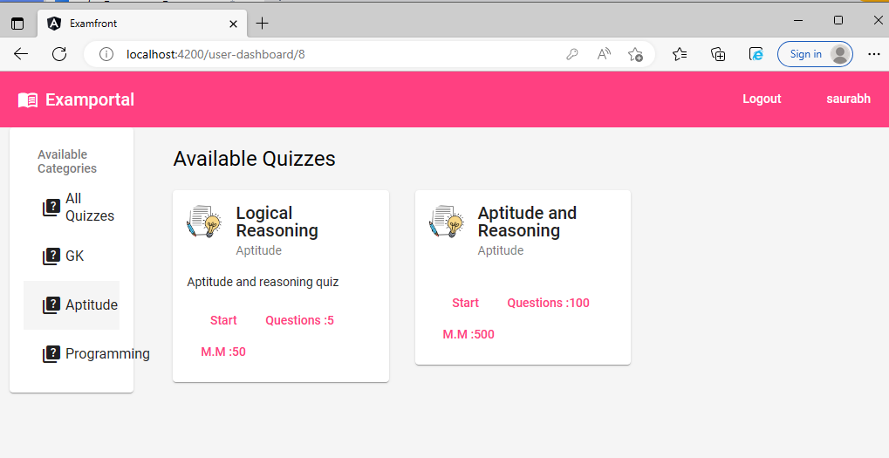

## Programming Quiz:

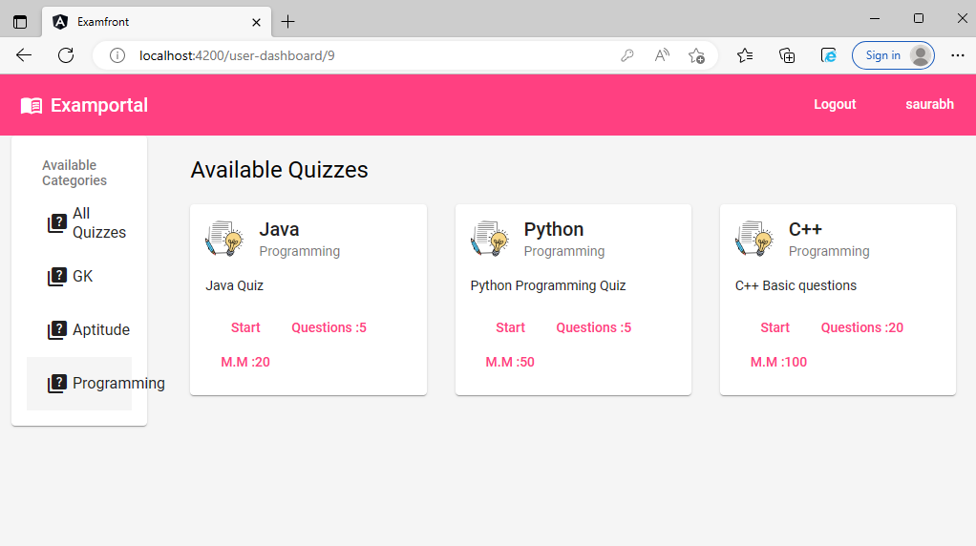

## Quiz Instruction Page:

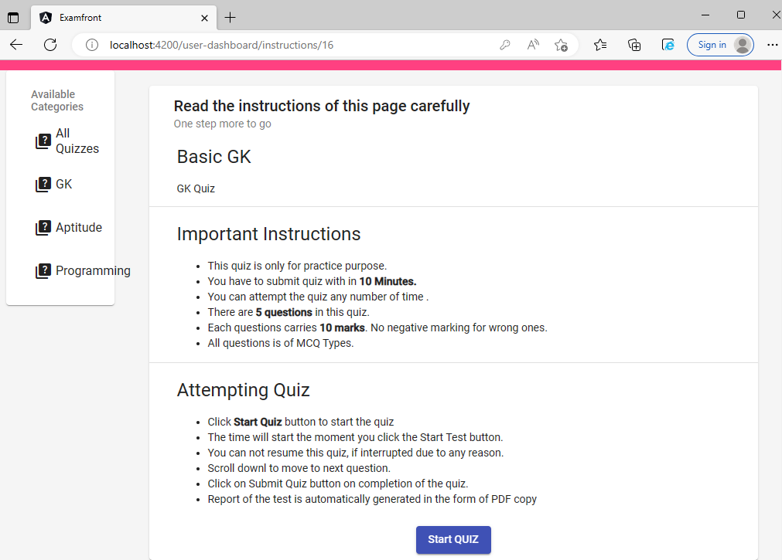

## Quiz Start Page:

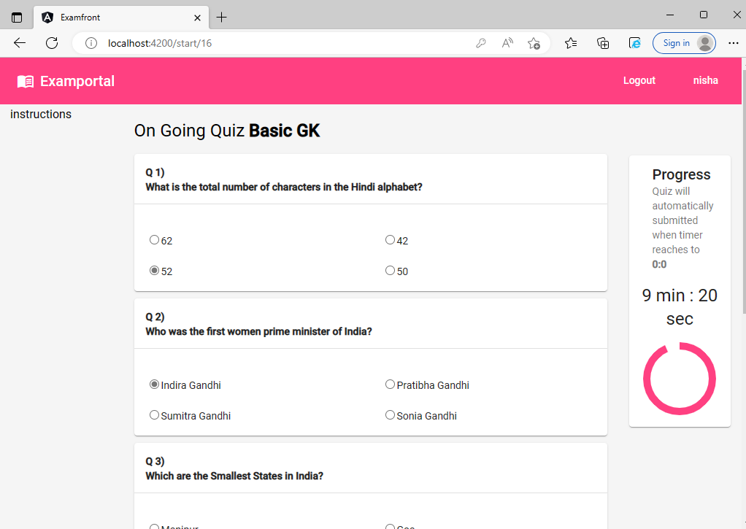

## Quiz Result Page:

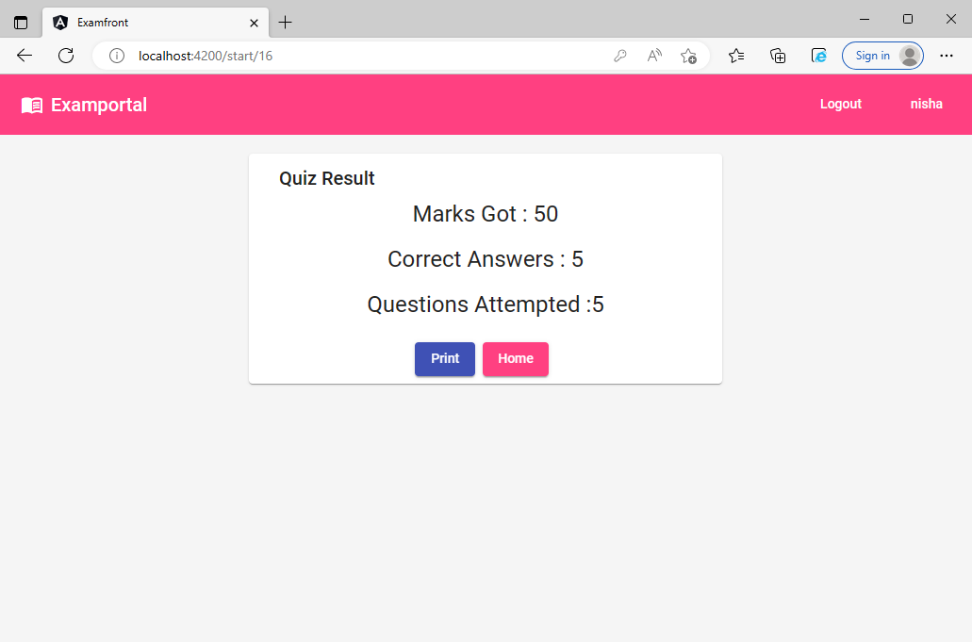

**ThankYou!!!.**